Tạo file home

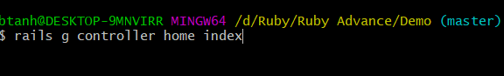

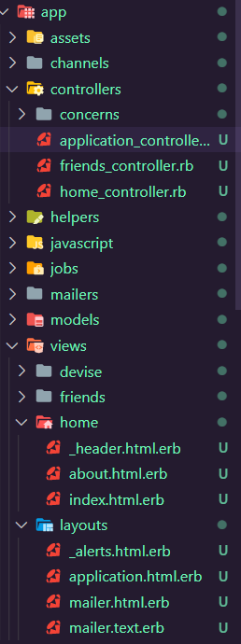

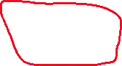



Kiểm tra phương thức và đường dẫn

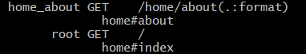



Trong file config/routes sửa

Root : khi link đến trang localhost:3000 sẽ trỏ đến trang home#index làm trang chủ

Rails.application.routes.draw do

*# get 'home/index'*

  get 'home/about'

  root 'home#index'

*# For details on the DSL available within this file, see https://guides.rubyonrails.org/routing.html*

end

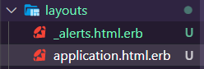

Tạo file _alerts.html.erb để hiện thông báo. Xóa các <%= notice %> trong các thư mục khác

<div *class*="alert alert-success alert-dismissible fade show" *role*="alert">

    <%= notice %>

  <button *type*="button" *class*="close" *data-dismiss*="alert" *aria-label*="Close">

    <span *aria-hidden*="true">&times;</span>

  </button>

</div>

Add Bootrap to file : <https://getbootstrap.com/docs/4.6/getting-started/introduction/#starter-template>

Trong file application.html.erb sửa như sau :

<!doctype *html*>

<html *lang*="en">

  <head>

*<!-- Required meta tags -->*

    <meta *charset*="utf-8">

    <meta *name*="viewport" *content*="width=device-width, initial-scale=1, shrink-to-fit=no">

    <%= csrf_meta_tags %>

    <%= csp_meta_tag %>

    <%= stylesheet_link_tag 'application', media: 'all', 'data-turbolinks-track': 'reload' %>

    <%= javascript_pack_tag 'application', 'data-turbolinks-track': 'reload' %>

*<!-- Bootstrap CSS -->*

    <link *rel*="stylesheet" *href*="https://cdn.jsdelivr.net/npm/bootstrap@4.6.1/dist/css/bootstrap.min.css" *integrity*="sha384-zCbKRCUGaJDkqS1kPbPd7TveP5iyJE0EjAuZQTgFLD2ylzuqKfdKlfG/eSrtxUkn" *crossorigin*="anonymous">

    <title>Demo</title>

  </head>

  <body>

  <%= render 'home/header' %>

  <div *class*="container">

  <% if notice%>

  <%= render 'layouts/alerts'%>

  <% end %>

    <%= yield %>

  </div>

*<!-- Optional JavaScript; choose one of the two! -->*

*<!-- Option 1: jQuery and Bootstrap Bundle (includes Popper) -->*

    <script *src*="https://cdn.jsdelivr.net/npm/jquery@3.5.1/dist/jquery.slim.min.js" *integrity*="sha384-DfXdz2htPH0lsSSs5nCTpuj/zy4C+OGpamoFVy38MVBnE+IbbVYUew+OrCXaRkfj" *crossorigin*="anonymous"></script>

    <script *src*="https://cdn.jsdelivr.net/npm/bootstrap@4.6.1/dist/js/bootstrap.bundle.min.js" *integrity*="sha384-fQybjgWLrvvRgtW6bFlB7jaZrFsaBXjsOMm/tB9LTS58ONXgqbR9W8oWht/amnpF" *crossorigin*="anonymous"></script>

*<!-- Option 2: Separate Popper and Bootstrap JS -->*

*<!--*

*<script src="https://cdn.jsdelivr.net/npm/jquery@3.5.1/dist/jquery.slim.min.js" integrity="sha384-DfXdz2htPH0lsSSs5nCTpuj/zy4C+OGpamoFVy38MVBnE+IbbVYUew+OrCXaRkfj" crossorigin="anonymous"></script>*

*<script src="https://cdn.jsdelivr.net/npm/popper.js@1.16.1/dist/umd/popper.min.js" integrity="sha384-9/reFTGAW83EW2RDu2S0VKaIzap3H66lZH81PoYlFhbGU+6BZp6G7niu735Sk7lN" crossorigin="anonymous"></script>*

*<script src="https://cdn.jsdelivr.net/npm/bootstrap@4.6.1/dist/js/bootstrap.min.js" integrity="sha384-VHvPCCyXqtD5DqJeNxl2dtTyhF78xXNXdkwX1CZeRusQfRKp+tA7hAShOK/B/fQ2" crossorigin="anonymous"></script>*

*-->*

  </body>

</html>

Tạo file _header.html.erb trong thư mục Home

<nav *class*="navbar navbar-expand-lg navbar-dark bg-dark">

<%= link_to  'Friend App',

    root_path,

    class:"navbar-brand" %>

  <button *class*="navbar-toggler" *type*="button" *data-toggle*="collapse" *data-target*="#navbarSupportedContent" *aria-controls*="navbarSupportedContent" *aria-expanded*="false" *aria-label*="Toggle navigation">

    <span *class*="navbar-toggler-icon"></span>

  </button>

  <div *class*="collapse navbar-collapse" *id*="navbarSupportedContent">

    <ul *class*="navbar-nav mr-auto">

        <li *class*="nav-item">

        <%= link_to "About Us",

            home_about_path,

            class:"nav-link" %>

        </li>

      <% if user_signed_in? %>

         <li *class*="nav-item">

          <%= link_to "Show Friend",

              friends_path,

              class:"nav-link" %>

          </li>

          <li *class*="nav-item">

          <%= link_to "Add Friend",

              new_friend_path,

              class:"nav-link" %>

          </li>

          </li>

              <li *class*="nav-item">

        <%= link_to "Sign Out",

             destroy_user_session_path,

             method: :delete,

            class:"nav-link" %>

        </li>

              <li *class*="nav-item">

        <%= link_to "Edit Profile",

             edit_user_registration_path,

            class:"nav-link" %>

        </li>

      <% else %>

         <li *class*="nav-item">

        <%= link_to "Sign Up",

             new_user_registration_path,

            class:"nav-link" %>

        </li>

         <li *class*="nav-item">

        <%= link_to "Sign In",

             new_user_session_path,

            class:"nav-link" %>

      <% end %>

    </ul>

    <form *class*="form-inline my-2 my-lg-0">

      <input *class*="form-control mr-sm-2" *type*="search" *placeholder*="Search" *aria-label*="Search">

      <button *class*="btn btn-outline-success my-2 my-sm-0" *type*="submit">Search</button>

    </form>

  </div>

</nav>

Kết quả :

